# Homework 04 for machine learning

Uni: jg4185

Name: Jiaqing Ge

1 (a)

|  |  |  |  |  |  |  |  |
| --- | --- | --- | --- | --- | --- | --- | --- |
| Team names | Iteration 10 | Team names | Iteration 100 | Team names | Iteration 1000 | Team names | Iteration 10000 |
| NorthCentral | 0.012812 | LSU | 0.043642 | LSU | 0.084419 | LSU | 0.091366 |
| LSU | 0.012578 | Wheaton | 0.025822 | Clemson | 0.045527 | Clemson | 0.049262 |
| Morningside | 0.011511 | NorthCentral | 0.024442 | OhioState | 0.043452 | OhioState | 0.047009 |
| Wheaton | 0.011088 | Clemson | 0.023704 | Georgia | 0.032720 | Georgia | 0.035382 |
| MinnSt-Mankato | 0.009633 | OhioState | 0.022688 | Alabama | 0.024679 | Alabama | 0.026695 |
| Muhlenberg | 0.009507 | Morningside | 0.022621 | Florida | 0.023696 | Florida | 0.025624 |
| OhioState | 0.009241 | Georgia | 0.017165 | Oregon | 0.019266 | Oregon | 0.020779 |
| UW-Whitewater | 0.009165 | StJohnsMN | 0.014990 | Auburn | 0.019037 | Auburn | 0.020582 |
| NorthDakotaSt | 0.009137 | WestFlorida | 0.013367 | Oklahoma | 0.018703 | Oklahoma | 0.020202 |
| Clemson | 0.008941 | Alabama | 0.012917 | PennState | 0.017974 | PennState | 0.019429 |
| WestFlorida | 0.008785 | UW-Whitewater | 0.012836 | Wisconsin | 0.015165 | Wisconsin | 0.016392 |
| MarianIN | 0.008515 | Florida | 0.012440 | NotreDame | 0.014647 | NotreDame | 0.015820 |
| StJohnsMN | 0.008488 | Muhlenberg | 0.011238 | Minnesota | 0.014201 | Minnesota | 0.015347 |
| MountUnion | 0.007653 | Oregon | 0.010530 | Baylor | 0.012704 | Baylor | 0.013716 |
| FerrisSt | 0.007122 | Auburn | 0.010021 | Michigan | 0.012045 | Michigan | 0.013023 |
| GrandView | 0.007114 | Oklahoma | 0.010012 | Utah | 0.011703 | Utah | 0.012617 |
| Georgia | 0.007013 | MinnSt-Mankato | 0.009752 | Memphis | 0.011663 | Memphis | 0.012590 |
| MaryHardin-Baylor | 0.006778 | MarianIN | 0.009583 | Iowa | 0.011006 | Iowa | 0.011894 |
| Lenoir-Rhyne | 0.006163 | PennState | 0.009534 | AppalachianSt | 0.010923 | AppalachianSt | 0.011792 |
| SlipperyRock | 0.006088 | ValdostaSt | 0.008894 | Texas | 0.010187 | Texas | 0.011003 |
| Oregon | 0.005900 | Lenoir-Rhyne | 0.008070 | NorthDakotaSt | 0.009224 | Navy | 0.009785 |
| DelawareValley | 0.005840 | Wisconsin | 0.008019 | Navy | 0.009071 | NorthDakotaSt | 0.009717 |
| JamesMadison | 0.005666 | NotreDame | 0.007866 | TexasA&M | 0.008933 | TexasA&M | 0.009658 |
| ValdostaSt | 0.005544 | Minnesota | 0.007532 | BoiseSt | 0.008306 | BoiseSt | 0.008943 |
| Florida | 0.005437 | GrandView | 0.007521 | KansasSt | 0.007334 | KansasSt | 0.007916 |

(b)

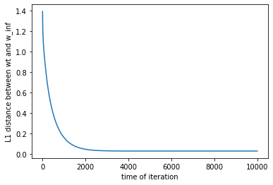

2

(a)

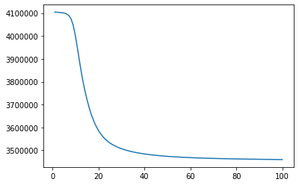

(b)